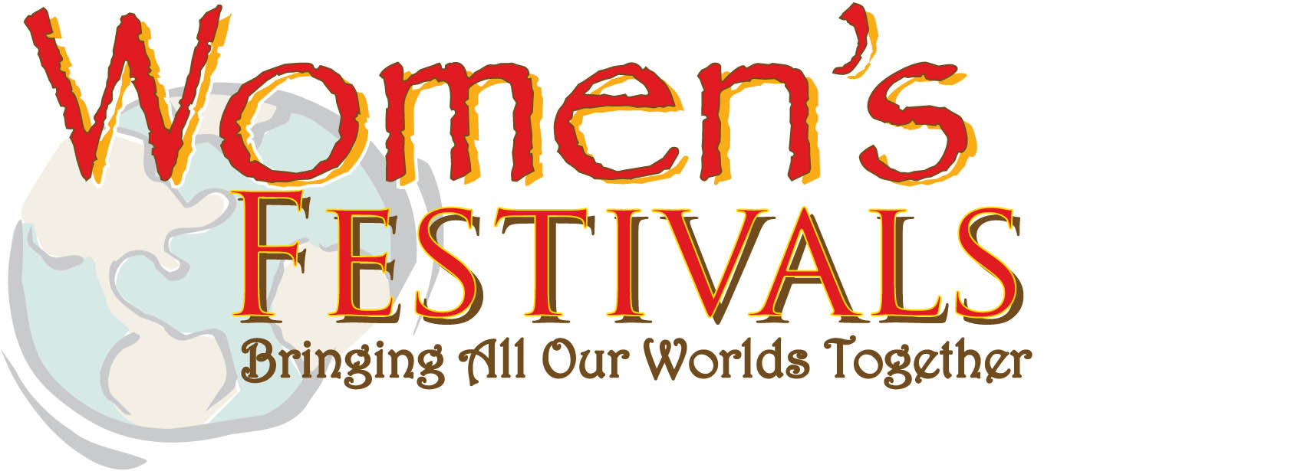

California – March 7 & 8, 2014 at Earl Warren Showgrounds, Santa Barbara, CA

2014 CALIFORNIA WOMEN’S FESTIVAL
VOLUNTEER APPLICATION

Name:
Address:
Cell:
E-mail:
Time available to volunteer (hours per week, day, etc.):

Please list your key professional and/or personal talents that you can offer to the Women’s Festivals:

After completing this form, please mail or fax it to:
Women’s Festivals | 805.565.9967 (ofc)
2353 E. Valley Rd. | 805.565.4166 (fax)
Santa Barbara, CA 93108 | info@womensfestivals.org

