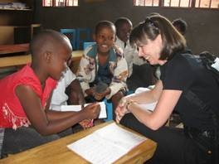

REBECCA TINSLEY ~ Conquering Post-Traumatic Stress: How Uganda's Former Child Soldiers Counsel Each Other

Rebecca Tinsley founded the charity, Network for Africa, helping survivors of genocide rebuild their lives. She supports 10 projects in Rwanda and Northern Uganda.

Rebecca also founded the human rights group, Waging Peace, after visiting Darfur at the height of the killing in 2004. Waging Peace collects evidence of human rights abuses in Sudan for the International Criminal Court. It pressures decision-makers to implement UN Security Council resolutions on Sudan.

Rebecca has a law degree from the London School of Economics. She is a former BBC politics reporter, a freelance journalist, and author of three novels.

