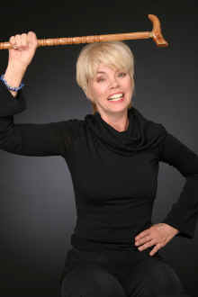

On the night of December 6th, 1978, while driving home I was broad sided by a truck. I fell into a coma and was handed a 1% chance to even wake up. I awoke five weeks later. Now that I am, I have not stopped.
I graduated from LIFE BIBLE College in 1989. The complete story is in my book, HOW I BECAME A FEARLESS WOMAN.
I speak to different groups about my story and how to never lose hope, or they will give in to that fear of defeat. Acting became a love of mine that I am not about to shake. I began studying in 2001 because, I realized... If I can't get there behind the camera, I'll get there in front!

